A Project Report
on

NAME OF PROJECT

Submitted for partial fulfillment of award of the degree of

BACHELOR OF TECHNOLOGY
In
COMPUTER SCIENCE & ENGINEERING


2021-22
Under the Guidance of Submitted By
(Name of Guide) Names( Univ. Roll Nos.)
(Designation)

DEPARTMENT OF COMPUTER SCIENCE & ENGINEERING
I.T.S ENGINEERING COLLEGE
46, KNOWLEDGE PARK-III, GREATER NOIDA

Affiliated from Dr. A.P.J Abdul Kalam Technical University, Lucknow
Session 2020-2024

Chapter 1
Introduction
  - Introduction

Saving is income not spent, or deferred consumption. Methods of saving include putting money aside in, for example, a deposit account, a pension account, an investment fund, or as cash Saving also involves reducing expenditures, such as recurring costs. In terms of personal finance, saving generally specifies low-risk preservation of money, as in a deposit account, versus investment, wherein risk is a lot higher; in economics more broadly, it refers to any income not used for immediate consumption. Saving does not automatically include interest.
Saving differs from savings. The former refers to the act of not consuming one's assets, whereas the latter refers to either multiple opportunities to reduce costs; or one's assets in the form of cash. Saving refers to an activity occurring over time, a flow variable, whereas savings refers to something that exists at any one time, a stock variable. This distinction is often misunderstood, and even professional economists and investment professionals will often refer to "saving" as "savings"
In different contexts there can be subtle differences in what counts as saving. For example, the part of a person's income that is spent on mortgage loan principal repayments are not spent on present consumption and is therefore saving by the above definition, even though people do not always think of repaying a loan as saving. However, in the U.S. measurement of the numbers behind its gross national product (i.e., the National Income and Product Accounts), personal interest payments are not treated as "saving" unless the institutions and people who receive them save them.
Saving is closely related to physical investment, in that the former provides a source of funds for the latter. By not using income to buy consumer goods and services, it is possible for resources to instead be invested by being used to produce fixed capital, such as factories and machinery. Saving can therefore be vital to increase the amount of fixed capital available, which contributes to economic growth.
However, increased saving does not always correspond to increased investment. If savings are not deposited into a financial intermediary such as a bank, there is no chance for those savings to be recycled as investment by business. This means that saving may increase without increasing investment, possibly causing a short-fall of demand (a pile-up of inventories, a cut-back of production, employment, and income, and thus a recession) rather than to economic growth. In the short term, if saving falls below investment, it can lead to a growth of aggregate demand and an economic boom. In the long term if saving falls below investment it eventually reduces investment and detracts from future growth. Future growth is made possible by foregoing present consumption to increase investment. However, savings not deposited into a financial intermediary amount to an (interest-free) loan to the government or central bank, who can recycle this loan.
In a primitive agricultural economy, savings might take the form of holding back the best of the corn harvest as seed corn for the next planting season. If the whole crop were consumed the economy would convert to hunting and gathering the next season.

Saving in personal finance
Within personal finance, the act of saving corresponds to nominal preservation of money for future use. A deposit account paying interest is typically used to hold money for future needs, i.e. an emergency fund, to make a capital purchase (car, house, vacation, etc.) or to give to someone else (children, tax bill etc.).
Within personal finance, money used to purchase stocks, put in an investment fund or used to buy any asset where there is an element of capital risk is deemed an investment. This distinction is important as the investment risk can cause a capital loss when an investment is realized, unlike cash saving(s). Cash savings accounts are considered to have minimal risk. In the United States, all banks are required to have deposit insurance, typically issued by the Federal Deposit Insurance Corporation or FDIC. In extreme cases, a bank failure can cause deposits to be lost as it happened at the start of the Great Depression. The FDIC has prevented that from happening ever since.
In many instances the terms saving and investment are used interchangeably. For example, many deposit accounts are labeled as investment accounts by banks for marketing purposes. As a rule of thumb, if money is "invested" in cash, then it is savings. If money is used to purchase some asset that is hoped to increase in value over time, but that may fluctuate in market value, then it is an investment.
  - Importance and needs
We need saving management system to track records of our savings, especially where we spending our savings and how much and also keeps records of deposits means how much money we deposited. Through that we can make short term goals that this amount of money we have to save this week through saving management system we easily keeps check on how good or bad we working on our goal, through that there is a feature that helps you to give guidance on how much money you should invest in different sector like crypto market, stock market, mutual fund and many more things.

Chapter 2
System Requirement Specification

2.1. Hardware Requirements:
- Processor – Pentium 4
- RAM – 1 GB
- Hard Disk – 40GB
- Mouse – Standard Mouse
- Keyboard – Logitech Keyboard
- Processor Speed – 2.4GHZ
2.2. Software Requirements:
- Operating System – Microsoft Windows 10 or more
- Back-End – Visual Studio Code
2.3. Display Mode:
- Color Quality – Highest [32 bit]
- Screen Resolution – 1024 by 768 Pixels
Chapter 3
Requirement Analysis and Specification

3.1. Existing System:
- The existing system is manual system.
- The manual system is prone to error.
- This system involves a lot of manual entries with the application to perform a desired task.
- Usage of papers and records in the process leads to less efficiently less productivity.
- Increase lots of mistakes while writing in paper.
- Time delay between the user and customer is reduced.
- For this reason, the new system in invented.
3.2. Proposed System:

The system customer transactions, satisfies the requirements of the existing system in full-fledged manner. Through this system, customer can make fast transactions and view the last transactions easily.
3.3. System Analysis:

Understand the problem before the system to create analysis model there is a tendency to rush to a solution, even before the problem is understood.
Develop prototypes that enables user to understand how human/machine interaction will occur. Since the perception of the quality of software is often based on the perception of the “friendliness” of the interface prototyping is highly recommended.
Record the origin of and the reason for every requirement. This is the first step-in establishing traceability back to the customer.
Use multiple views of requirements building data, functional and behavioral models provide the software engineer with three different views. This reduces the likelihood that something will be missed and increases the likelihood that inconsistency will be recognized.
Rank requirements. Tight deadlines may preclude the implementation of every software requirement to be delivered in the first increment must be identified.
Work to eliminate ambiguity because most requirements are described in a natural language, the opportunity for ambiguity abounds.
3.4. System planning:

- Analysis principles are applied and a model of the software to be build called a planning (prototype) is constructed for customer and developer assessment.
- The close-ended approach is often called throwaway prototyping using this approach a prototype serves solely as a rough demonstration of requirements it is then discarded and the software is engineered using a different paradigm.
- An open-ended approach, called evolutionary prototyping uses the prototype as the first part of an analysis activity that will be continued into design and construction the prototype of the software is the first evolution of the finished system.
Chapter 4
Project Modules Design/ Database Design/ Software Features

The project saving management system have six sections or modules in the code and those are:
Main function: main function is where the function dashboard gets called and the value of balance returns.
Dashboard function: where the program askes you about your choice to withdraw money, deposits, check, or gets suggestion for investment
Withdraw function: withdraw function takes values from your balance and makes changes in your balance as you asked to do that.
Deposit function: deposit function takes values from your balance and makes changes in your balance as you asked to do that.
Checking function: checking function shows the balance of your savings.
Investment function: investment function askes your age and though that give the proper division of your investment amount and divides that into low risk and high risk portion which will give you idea about how much money you should invest in the different sector of investment.
Chapter 5
Testing and Evaluation

Software testing is a critical element of software quality assurance and represents the ultimate review of specification, design and code generation. The increasing visibility of software as a system element and the attendant “cost” associated with a software failure are motivating force for well planned, through testing.
5. Testing:
- Testing is the one of step in the software process that could be viewed as destructive rather than constructive.
- Software is tested from different perspectives:
- White box test.
- Black box test.
5.1 Whitebox Test:
White box tests focus on the program control structure, internal program logic is exercised using these techniques.
5.2 Blackbox Test:
Black box testing is software requirements are exercised and derive sets of inputs conditions that will fully exercise all functional requirements for a program this testing is also called “behavioral testing”.
5.3 Level of Testing:
The details of software functionality & test conditions are satisfied fully on behavioral based so that choose for black box testing.
5.3.1 Blackbox Testing:
- by incorrect or missing function
- applying block box testing in my project “saving management system”
- interface errors
- errors in external database access behavior (or) performance error
- initialization and termination error its mainly used for uncover errors in software functions
5.3.2 Behavioral testing:
It is possible to simulate the behavior of a real time system and consequence of external events.
5.3.3 System Testing:
Software and hardware are integrated and full range of system test is conducted so that we check for interrupt priority and the performance of each interrupt handling procedures. In this test check on each option of banking process.
Chapter 7
Limitations

- The first limitation of this program is this program is not for big values like it can calculate up 25 lacs but if your savings exceeds from this is it start giving garbage values.
- It doesn’t have fancy and colorful interface it is just black and a simple in design.
- Its investment portion is just giving the overview that how much money you should invest in different places.
Chapter 8
Future Scope

- We can add more detail in investment section of the program like companies or coins etc.
- We can add colors, more designs, and make it more accessible easy to use interface for users.
- We can also make this program accessible for mobile phones so we can reach up to more users.
- We can solve the one of its limitations and make useful for more than 25 lacs savings.
Conclusion

Saving and investing some money is important because it provides security stress relief, and freedom. And while there are countless reasons to save, you just need to find a reason that works with you. Whether its helping others, improving your finances, leaving a positive financial legacy, or just having a little more fun, you owe it to yourself to priorities savings.

TABLE OF CONTENTS

CHAPTER NO. TITLE PAGE NO.

CERTIFICATE ii
ACKNOWLEDGEMENT iii
ABSTRACT iv
1. 1. INTRODUCTION 1
1.1 Introduction 1
1.2 Saving in personal finance 2
1.3 Importance and need 2
2. 2. System Requirement Specification 3
2.1. Hardware Requirements 3
2.2. Software Requirements 3
2.3. Display Mode 3
3. 3. Requirement Analysis and Specification 4
3.1. Existing System 4
3.2. Proposed System 4
3.3. System Analysis 4
3.4. System planning 5
4. 4. Project Modules Design/ Database Design/ Software Features 6
5. 5. Testing and Evaluation 7
5. Testing 7
5.1 Whitebox Test 7
5.2 Blackbox Test 7
5.3 Level of Testing 7
5.3.1 Blackbox Testing 7
5.3.2 Behavioral testing 7
5.3.3 System Testing 8
6. 6. Project snapshots
7. 7. Limitations 10
8. 8. Future Scope 11
9. 9. Conclusion 12
Chapter 6
Project Snapshots
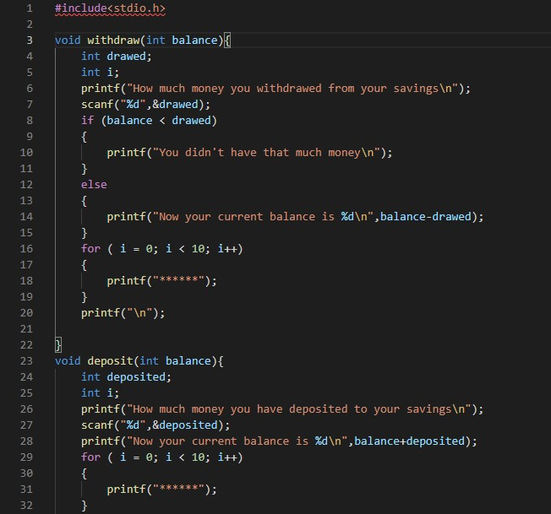

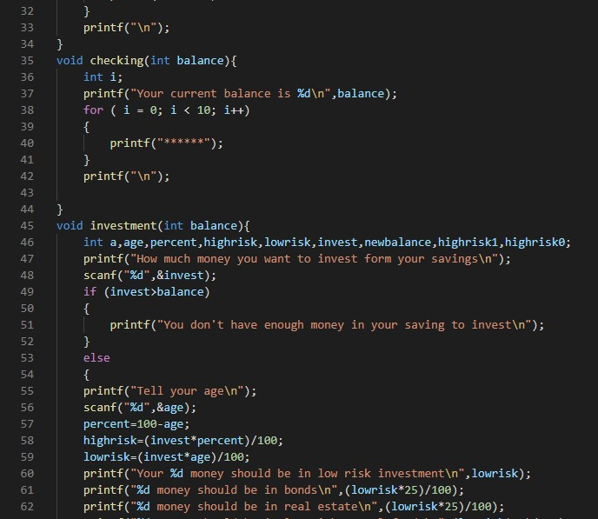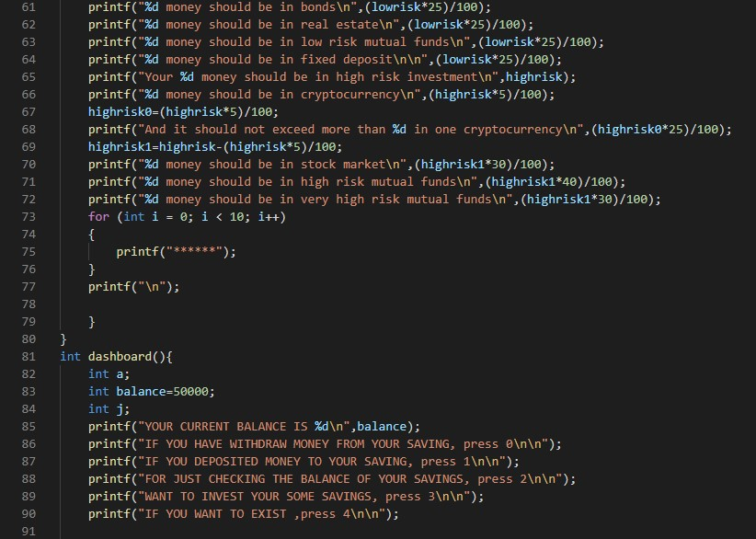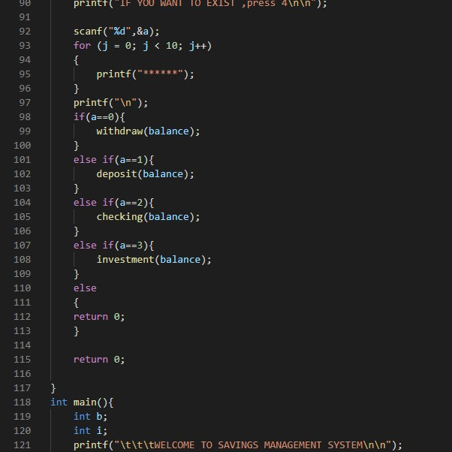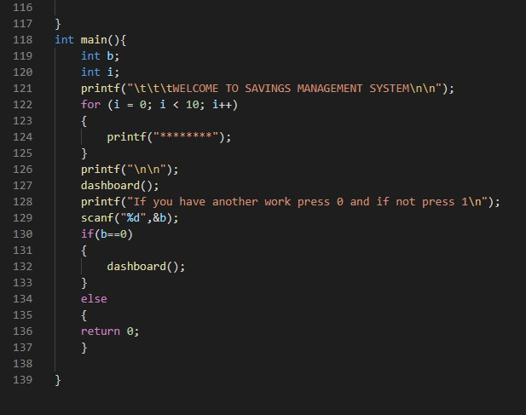

CERTIFICATE

Certified that Aryan Gaur has carried out the Project work presented in this project entitled “Saving management system” for the award of Bachelor of Technology from Dr. A.P.J. Abdul Kalam Technical University, Uttar Pradesh, Lucknow under my supervision. The Project embodies result of original work and studies carried out by Student himself and the contents of the Project do not form the basis for the award of any other degree to the candidate or to anybody else.

Dr. Vrinda Sachdeva
Associate Professor
Department of CSE
Date:

Dr. Ashish Kumar
HOD
(Department of CSE)

ABSTRACT

Savings is always a crucial part of life it helps you in many ways like gives you freedom to pursue your dream career, gives long term security, helps in emergencies, reduces future stress, sponsor your own education, minimizing financial risk, gives independence big purchases, leaving a financial legacy and many other ways. So that’s why savings should be tracked and you should have every record of your savings and with that this program will helps you to give you advise about how much money you should invest and where you should invest like in this program it only asks your age and with that age it will tell you that how much money you should invest in high risk and low risk and then after these low risk and high risk is further divided into some section like stocks, bonds, mutual funds, and this will give you proper idea that how much money you should invest in different financial markets with all that you can keep record of your withdraw, deposit and with that you can always checks your savings balance.

ACKNOWLEDGEMENT

It gives us a great sense of pleasure to present the Report of the Project “Saving management system” undertaken during B.Tech second Year. First and foremost, we wish to thank our Guide Prof. Dr. Vrinda Sachdeva (Department of Computer Science and Engineering, I.T.S. Engineering College, Greater Noida) for his kind blessings to us. She allowed us the freedom to explore, while at the same time provided us with invaluable sight without which this Project would not have been possible.
We also do not like to miss the opportunity to acknowledge the contribution of all faculty members of the Department for their kind assistance and cooperation during the development of our project.

Name of Student Name of Student
(Roll no.) (Roll no.)

Bibliography

www.geeksforgeeks.com
www.codingninja.com
www.reddit.com
www.stackoverflow.com
www.HackerRank.com
www.freeCodeCamp.com

